Writing Task: Write a walking tour of an area you know well.
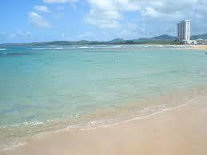

We Puerto Ricans are really lucky, because around this beautiful island you can find a lot of interesting places to give a visit. Puerto Rico is one of those beautiful Places where you can go and visit with your Family and Friends on a vacation. It’s very impressive how nature has gifted us these views where you can connect with love ones or by yourself. We have 2 languages: Spanish (Official) and English. The Island is well known for its low cost trips.

A Good Walk that I take with my family sometimes during Weekends is at Luquillo beach. On your way you will be able to see incredible places created by Mother Nature. The first stop is in the Road (Calle) Marginal near the Express. Next stop is in Los Kioscos de Luquillo, this is where you can find delicious meals and beverage. Then if you keep walking around los kioscos you will see the blue beautiful water and the sand. This picture is very near El Yunque Natural Forest. In places like this you can relax, play and feel the sand and feel free.

